Separation of Powers and Who Represents You?
What are the 3 powers in Australian Government and what are the roles of each
*
*
*
How can Australia’s Constitution be changed?

Who is Australia’s Head of State?

Who represents that person in Australia?

How does a person become elected to the House of Representatives?

What is the name of the Prime Minister?

What is the name of your Federal Member of Parliament and what is their electorate called?

Name some Federal Ministries

What is the role of the Cabinet and who are its members?

Who is the President of the Australian Senate?

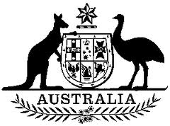
Who are the Senators for your State?

Who is the Chief Justice of the High Court?

